**RDBMS & SQL Assignments**

Assignment 1: Analyze a given business scenario and create an ER diagram that includes entities, relationships, attributes, and cardinality. Ensure that the diagram reflects proper normalization up to the third normal form.

**email**

**phone**

**customer_id**

**name**

**address**

**CUSTOMER**

1:N

**Total_amount**

**Order_id**

**ORDER**

**Order_date**

**Customer_id**

v 1:N

**ORDER_ITEM**

**Order_id**

**Quantity**

M:1

**Item_id**

**MENU_ITEM**

1:N

**restaurant**

**Item_name**

**Item_id**

**price**

**RESTURANT**

Primary Key = customer_id, restaurant_id, item_id, order_id

Foreign Key = customer_id in ORDER, restaurant_id in MENU_ITEM, order_id in ORDER_ITEM

Assignment 2: Design a database schema for a library system, including tables, fields, and constraints like NOT NULL, UNIQUE, and CHECK. Include primary and foreign keys to establish relationships between tables.

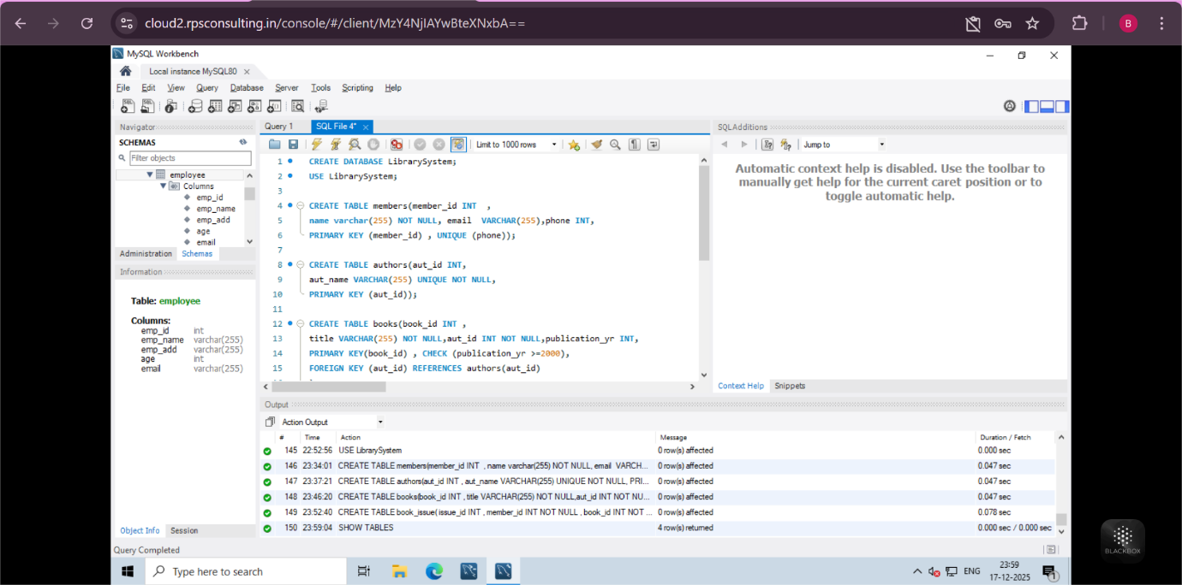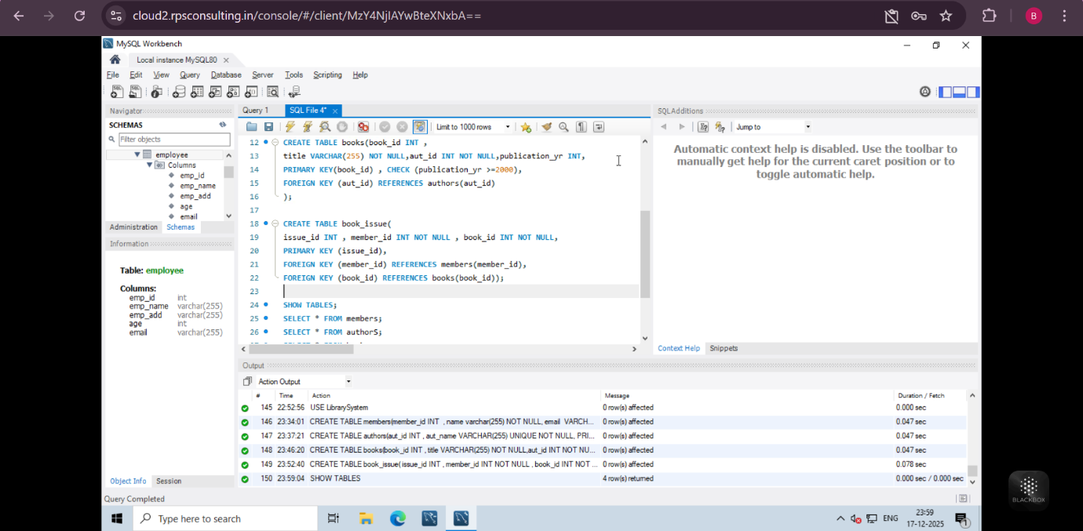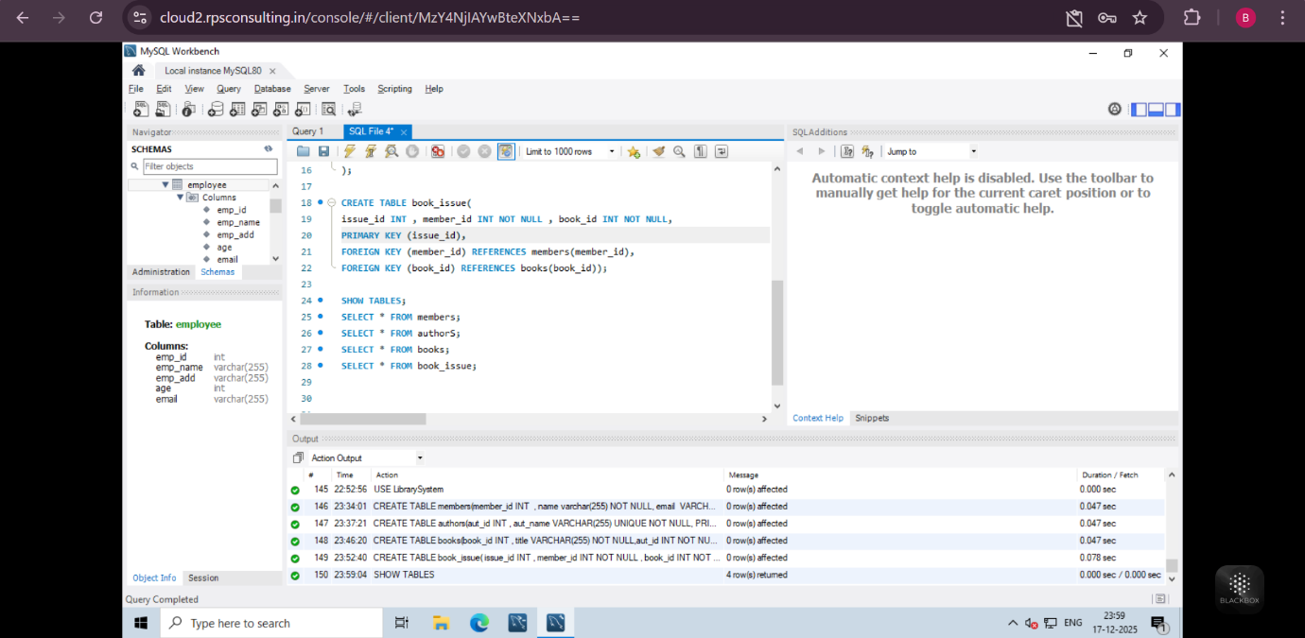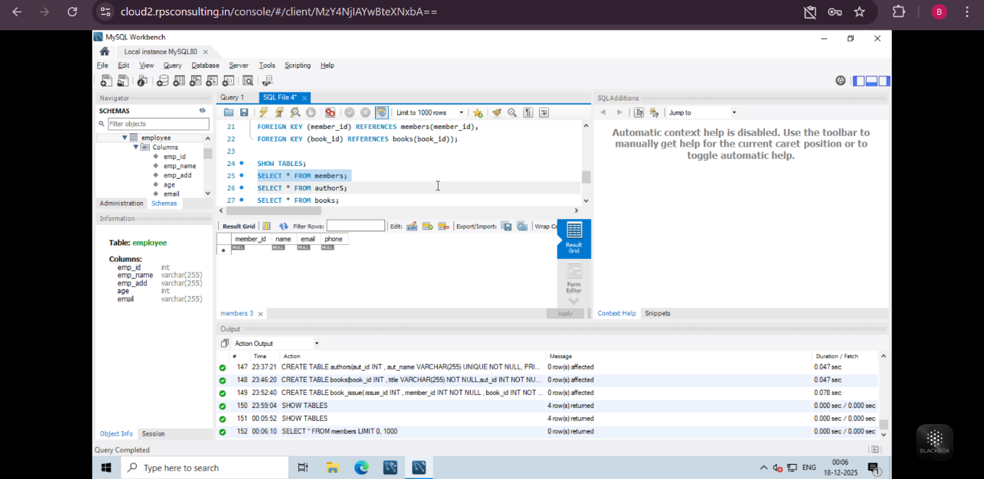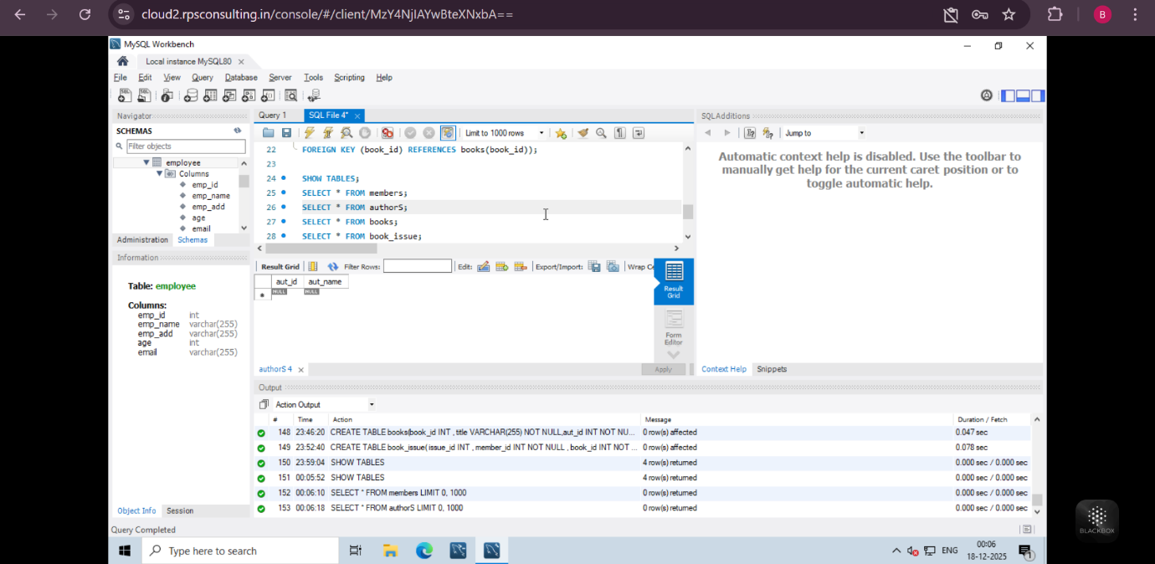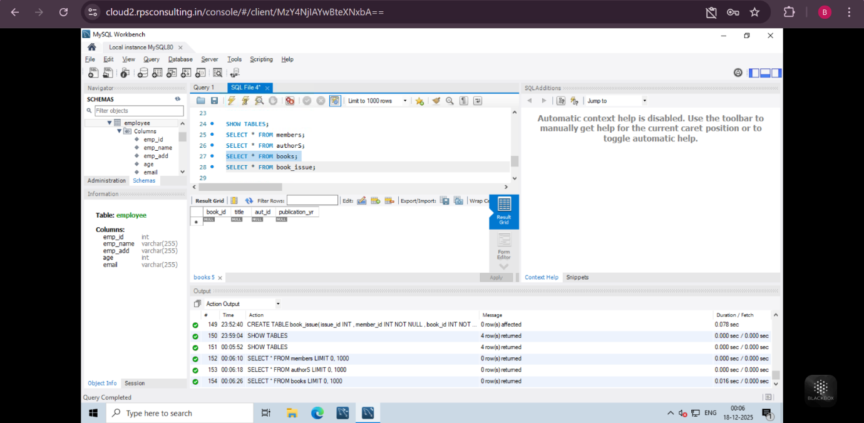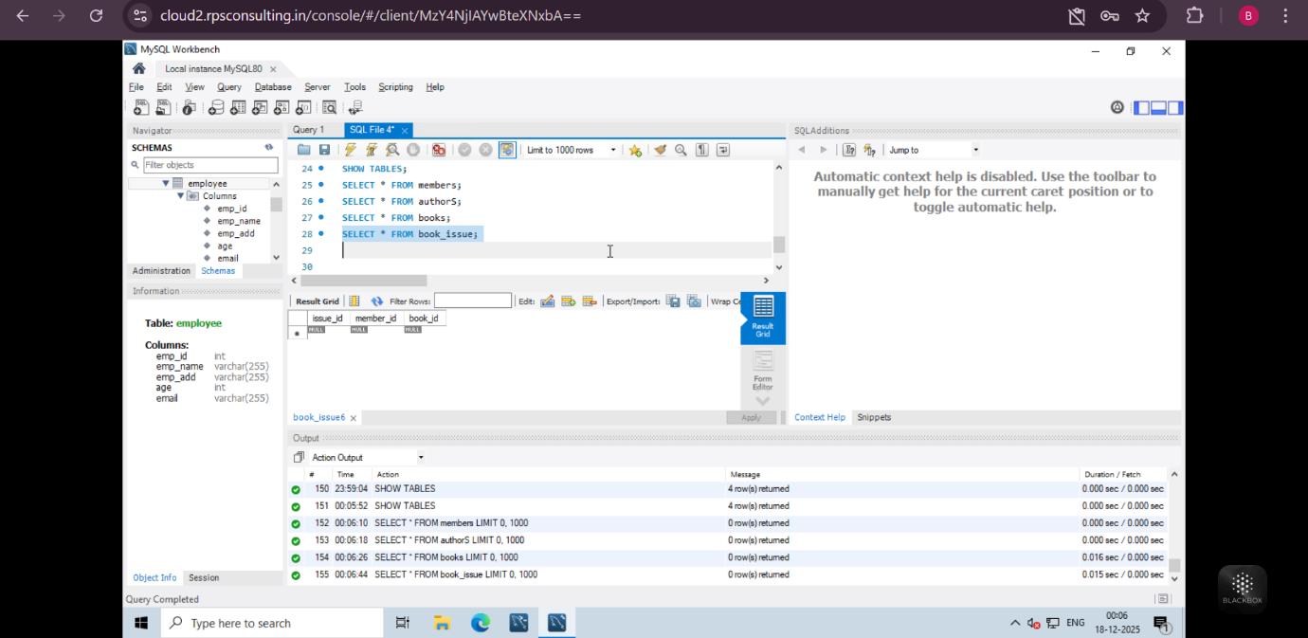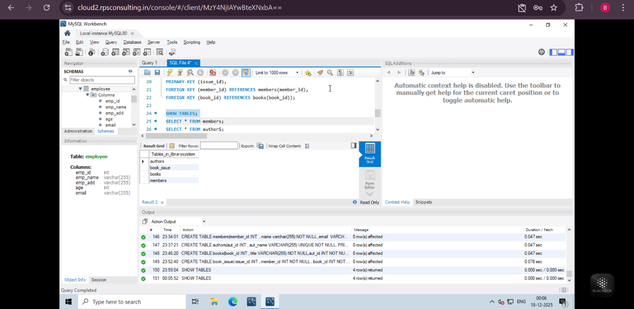

Assignment 3: Explain the ACID properties of a transaction in your own words. Write SQL statements to simulate a transaction that includes locking and demonstrate different isolation levels to show concurrency control.

ANS = **ACID**  properties ensure that database transactions are reliable and safe.

* **Atomicity**: In this either the transactions will be all or nothing.
* **Consistency:** This ensures that rules should not be broken.
* **Isolation:** Isolation ensures that transactions will be executed simultaneously, but will not affect each other.
* **Durability:**  In this case, if a transaction is saved, it will be saved permanently.

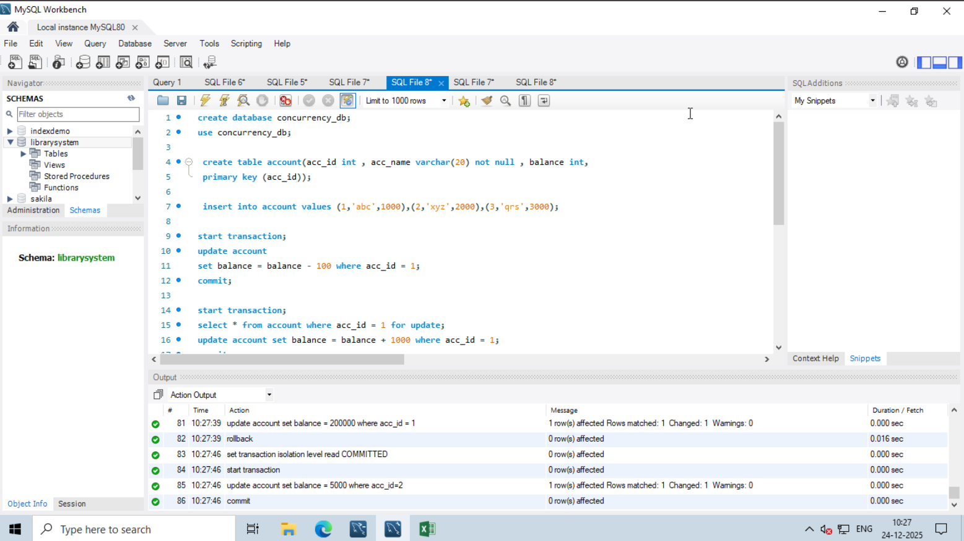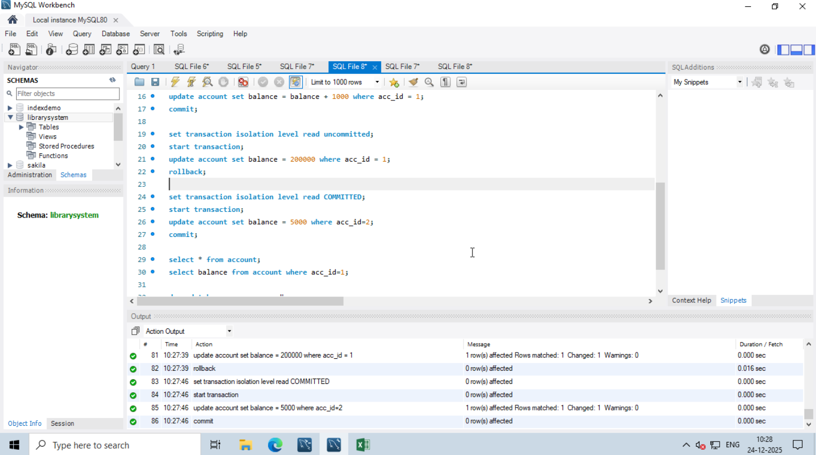

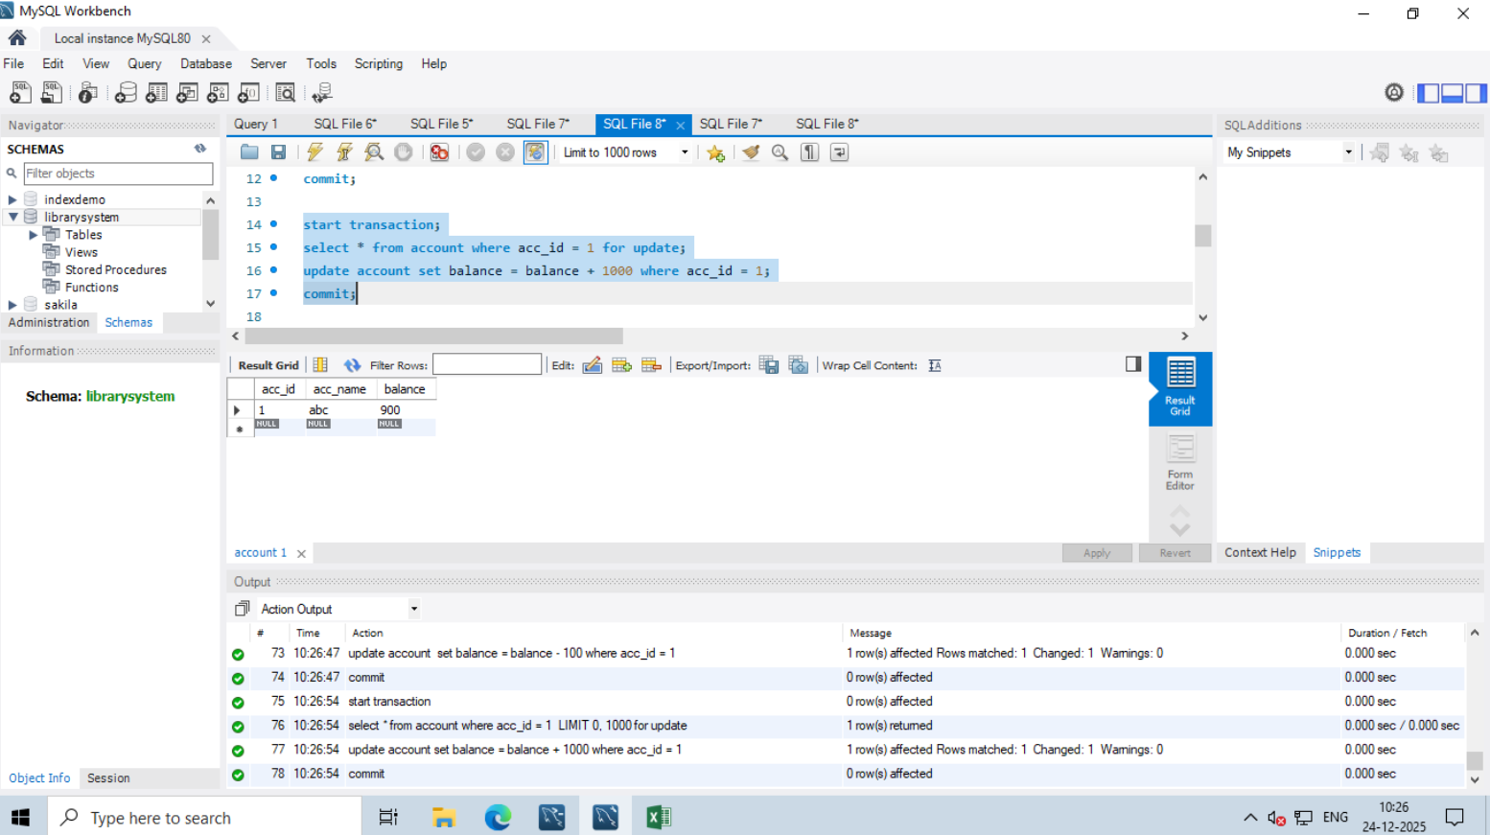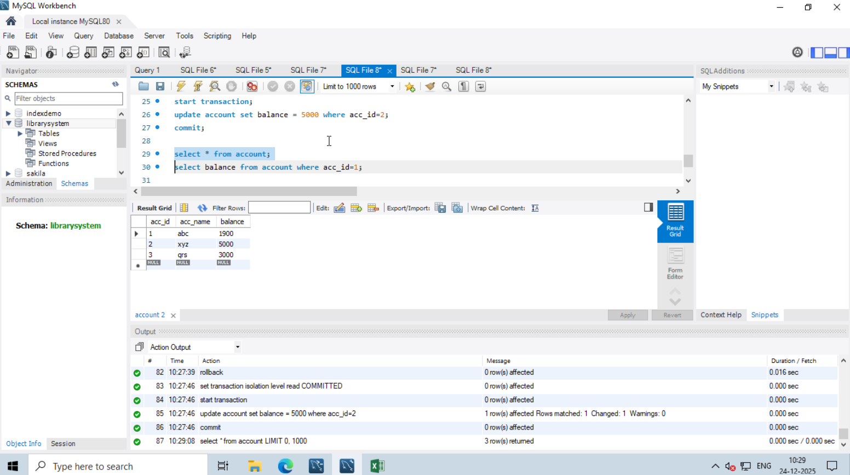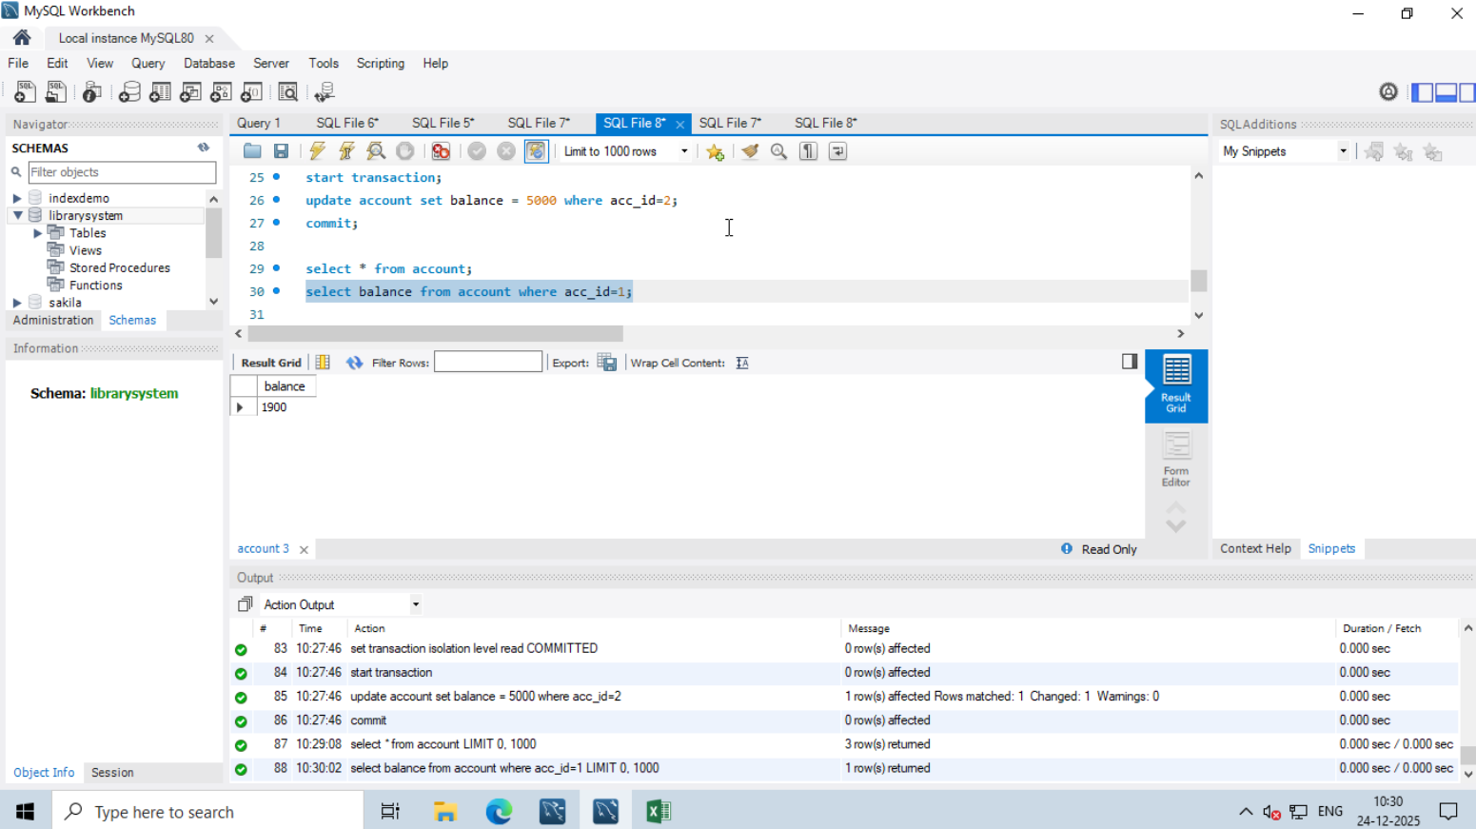

Assignment 4: Write SQL statements to CREATE a new database and tables that reflect the library schema you designed earlier. Use ALTER statements to modify the table structures and DROP statements to remove a redundant table.

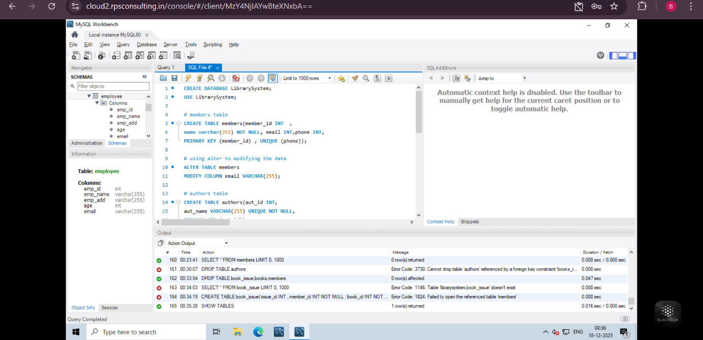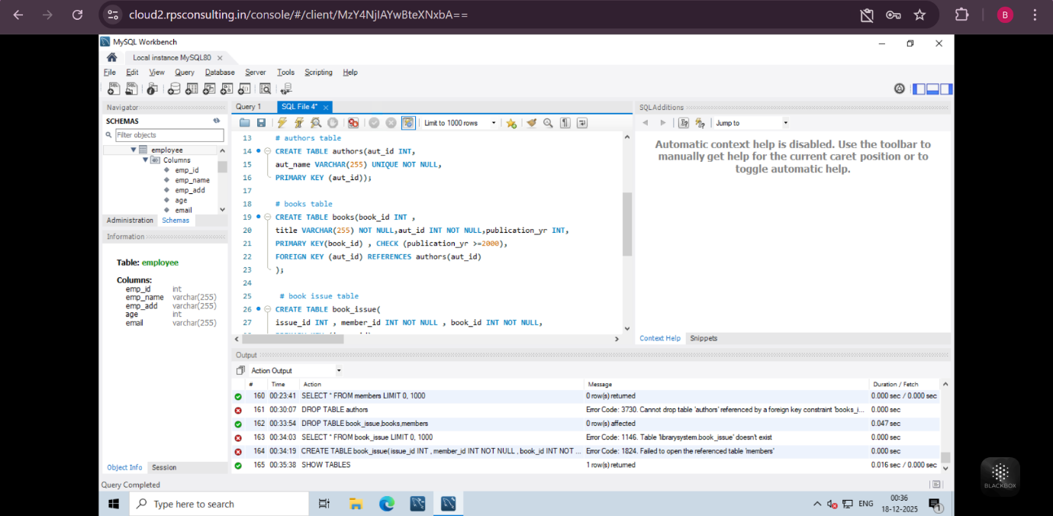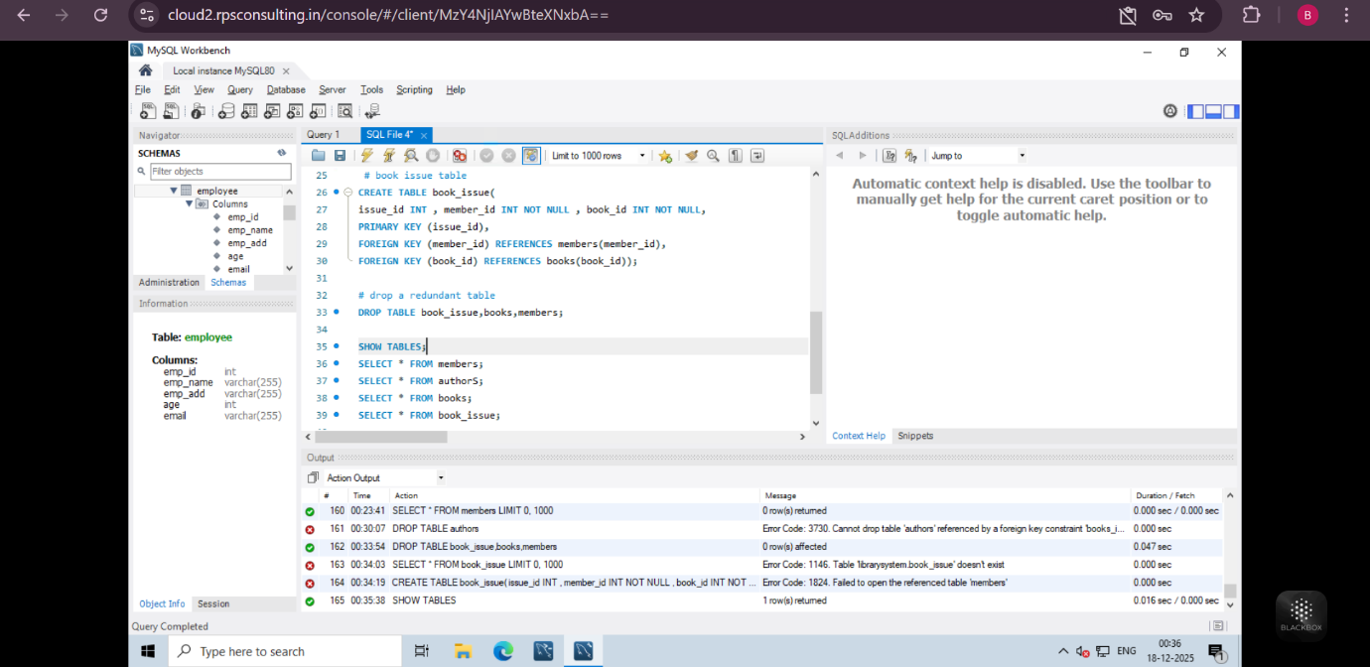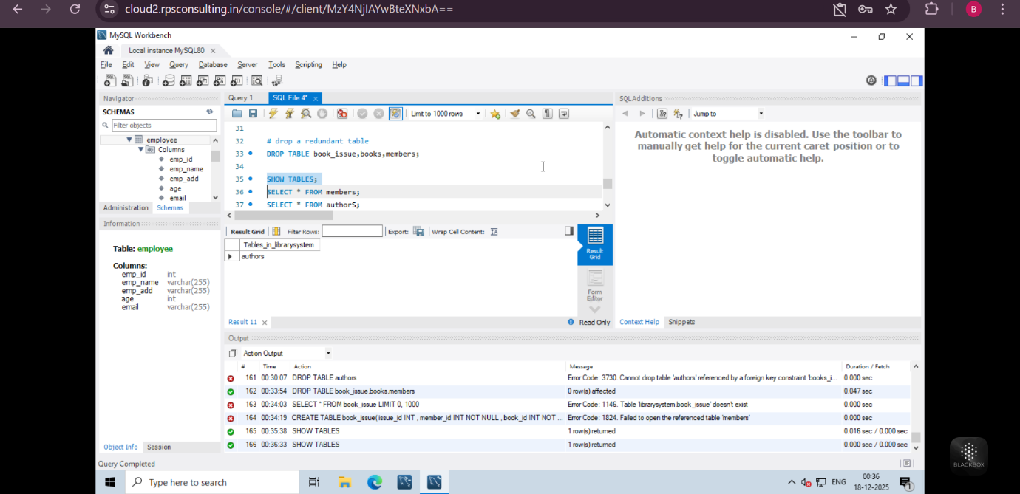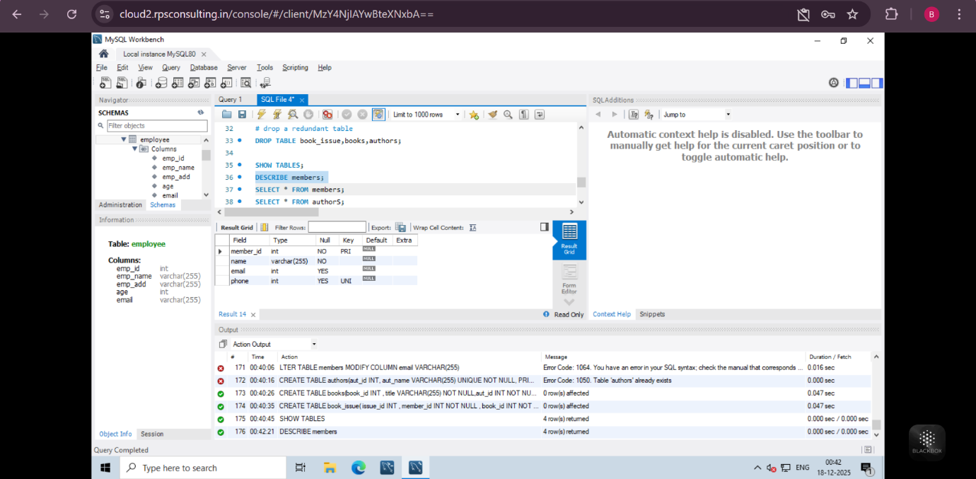

Assignment 2: Demonstrate the creation of an index on a table and discuss how it improves query performance. Use a DROP INDEX statement to remove the index and analyze the impact on query execution.

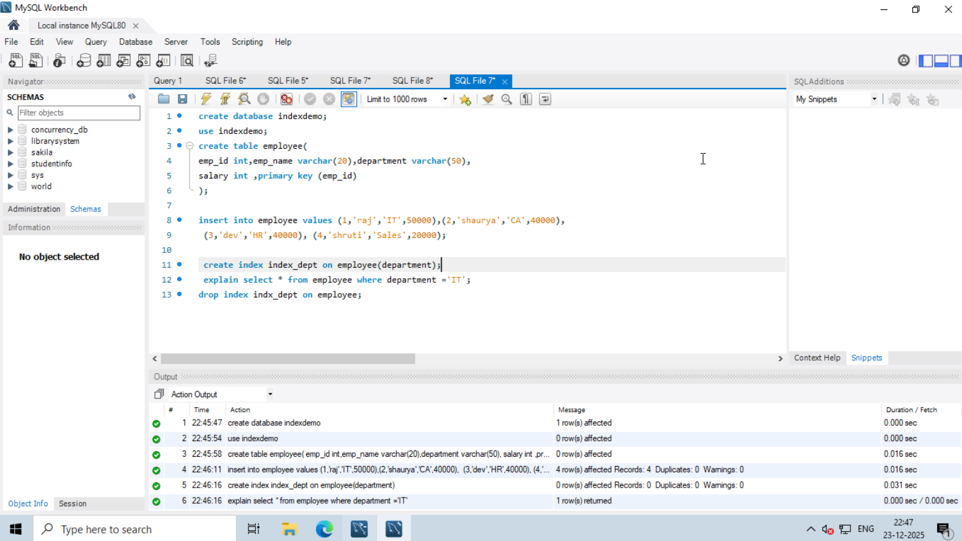

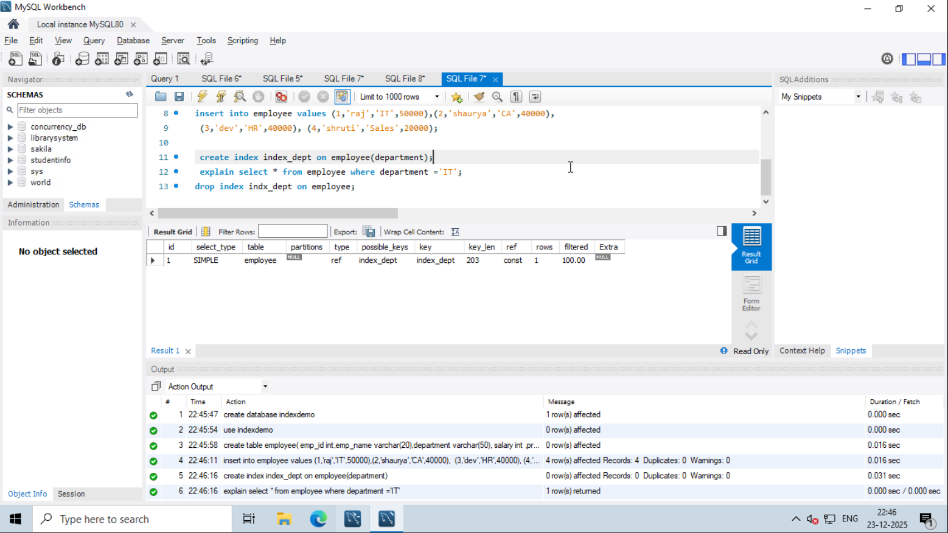

Assignment 6: Create a new database user with specific privileges using the CREATE USER and GRANT commands. Then, write a script to REVOKE certain privileges and DROP the user.

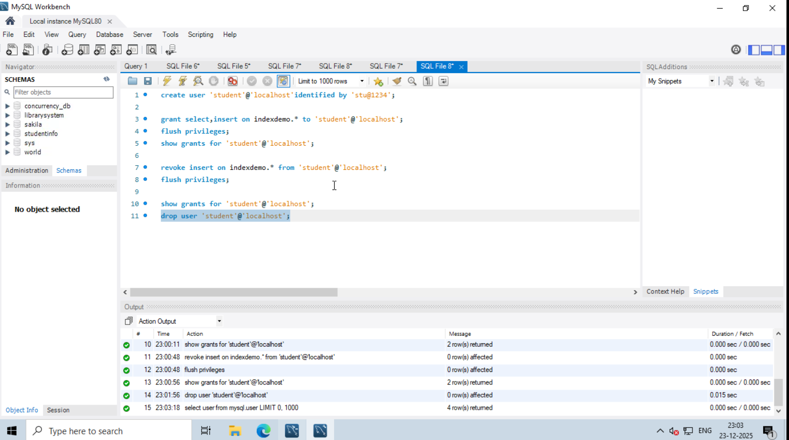

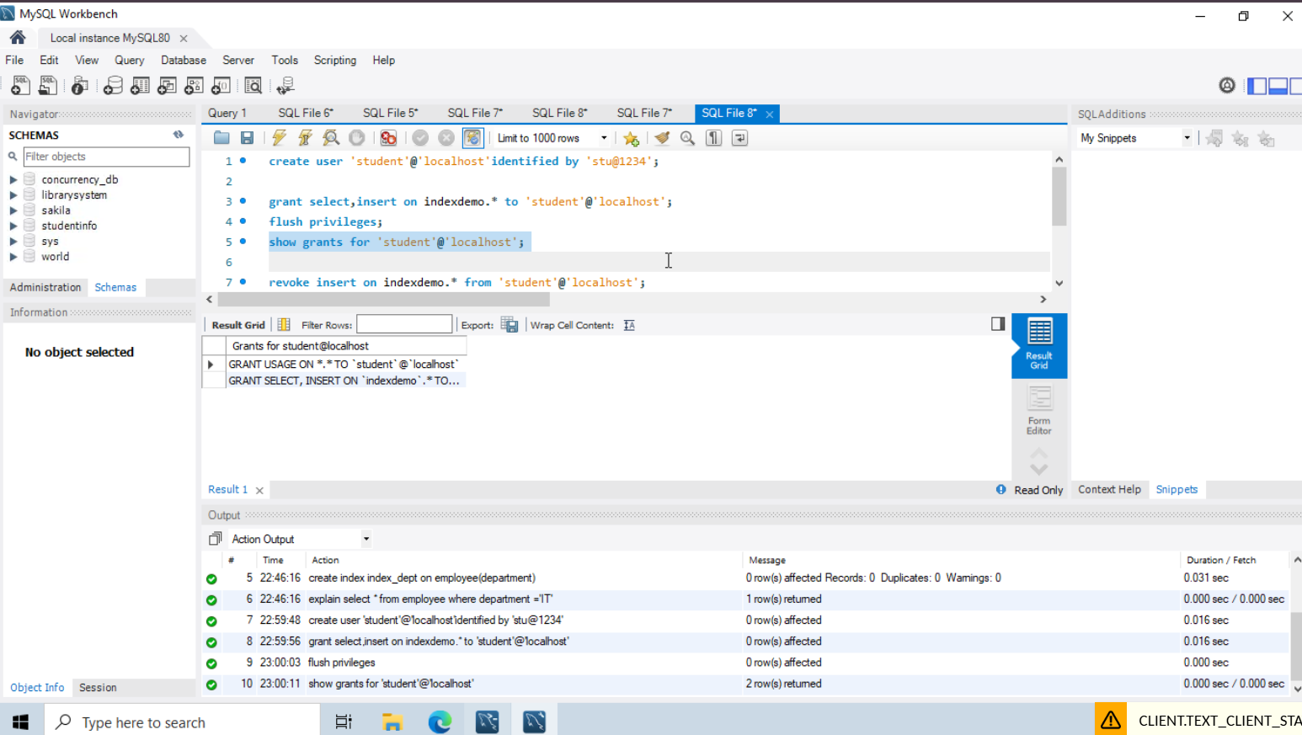

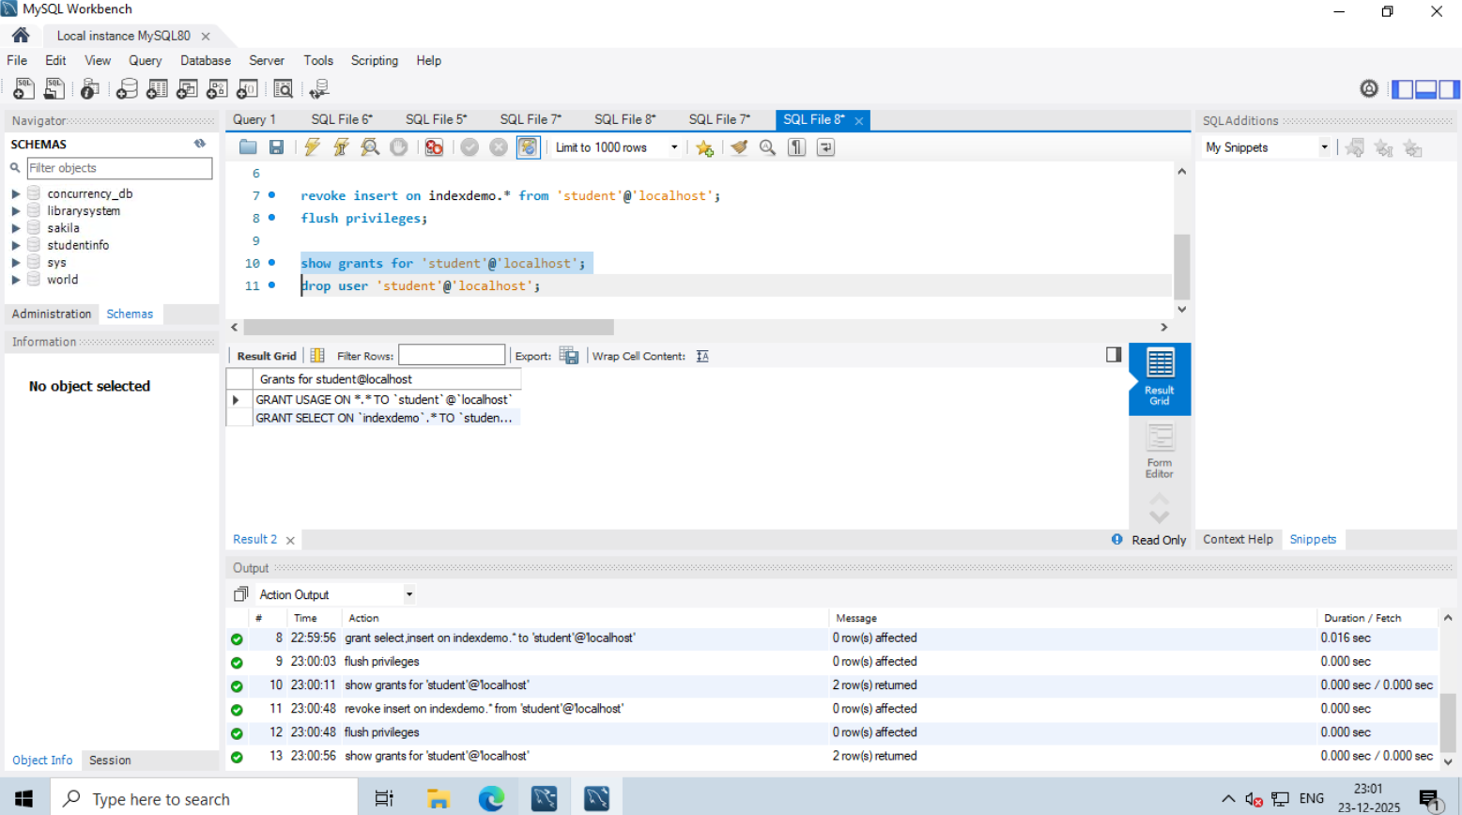

Assignment 7: Prepare a series of SQL statements to INSERT new records into the library tables, UPDATE existing records with new information, and DELETE records based on specific criteria. Include BULK INSERT operations to load data from an external source.

